 **QUAID-E-AWAM UNIVERSITY**  
 OF ENGINEERING, SCIENCE & TECHNOLOGY  
 NAWABSHAH, SINDH, PAKISTAN

**GROUP NAME (Game Changer**)

**PROJECT NAME:** HOSTEL MANAGEMENT SYSTEM

**GROUP LEADER:** SAYED AMJAD ALI SHAH (20IT32)

**TEAM MEMBER 1**: KHAIR MUHAMMAD KANHIO (20IT24)

**TEAM MEMBER 2**: AMJAD ALI (20IT31)

**TEAM MEMBER 3:** ARIF HUSSAIN VIGHIO (20IT49)

Contents

**Heading 1:** 2

Introduction: 2

**Heading 2:** 2

Features: 2

**Heading 3:** 2

Tools: 2

**Heading 4:** 4

Snapshots: 4

# **Heading 1:**

# Introduction:

Hostel management system is designed to manage all hostel activities like hostel admissions, fees, room, mess allotment, hostel stores & generates related reports for smooth transactions. It is also used to manage monthly mess bill calculation, hostel staff payroll.

# **Heading 2:**

# Features:

Systematic Control over Hostel Activities.

Accurate Student Data Management.

Complete Student Security.

Online Admission & Fees Management.

Room Allocation & Transfers.

Alerts & Notifications.

Mess Management.

Paperless Student Attendance.

# **Heading 3:**

# Tools:

-Frame Work

.NET, windowsform

-P. languages

C#

-IDE

Visual studio 2019

-UI Design

Login Design :

# **Heading 4:**

# Snapshots:

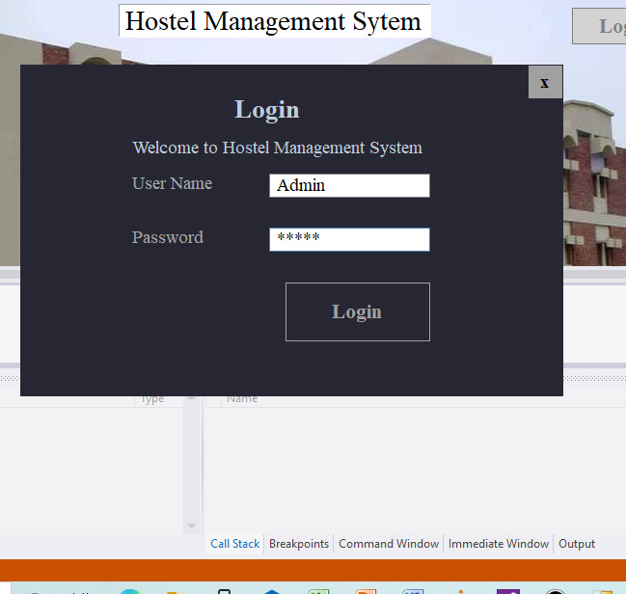

Main Form Design :

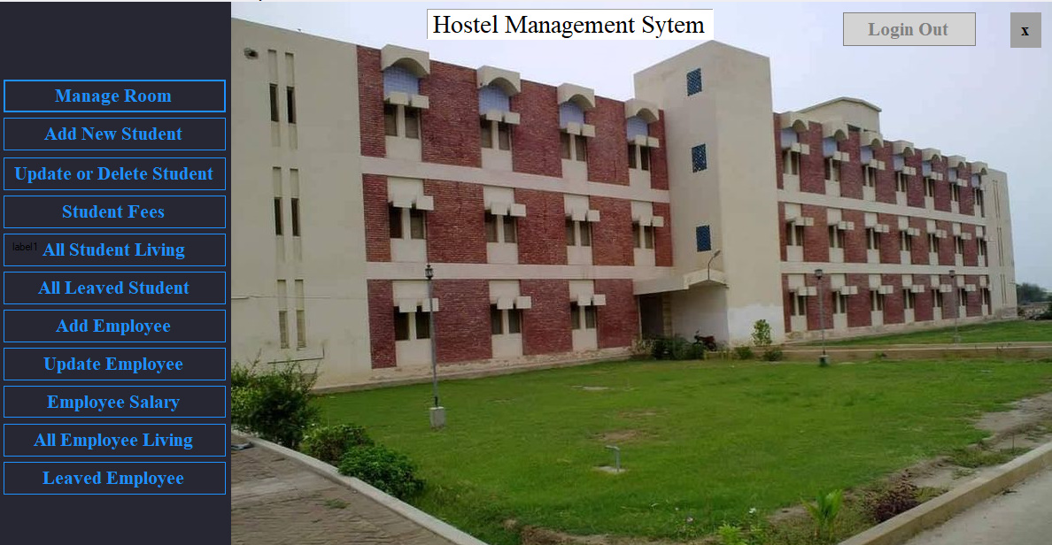

Manage Room Design:

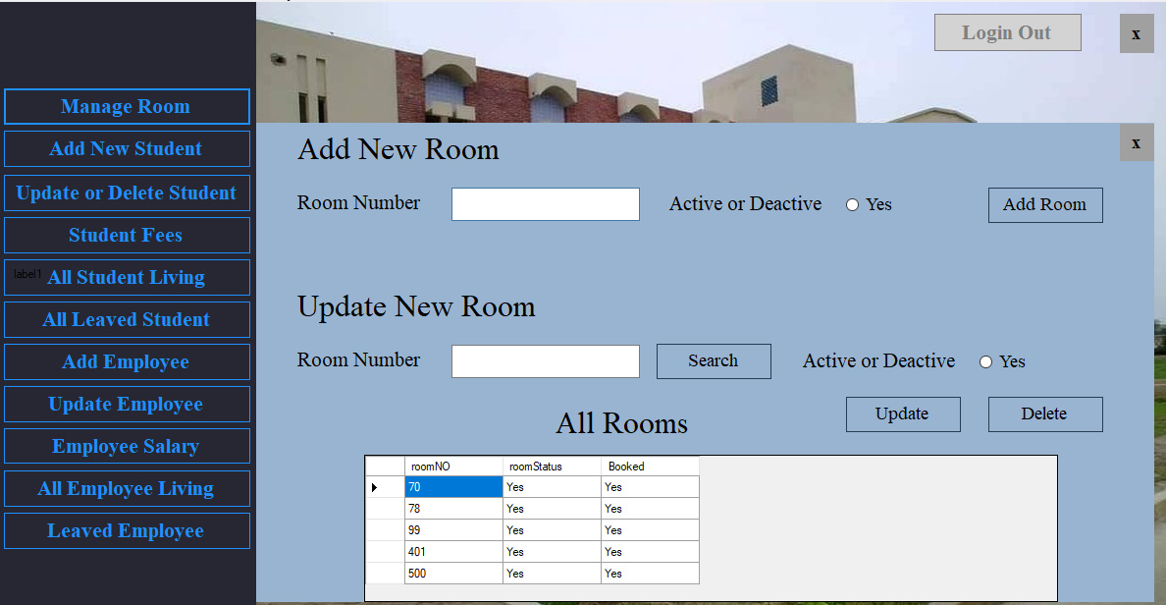

All Student Living Form Design: 